Quy Pham
G# 9909
ECE 320 – Project 1
Discrete Convolution
Fall 08 Sept 22
Matlab Project 1 – Discrete Convolution

- Introduction:
In this project we will be using a Matlab function conv() to do the convolution of an input signal and an impulse response. This project is divided into three sections. First section will be mainly on getting familiar with the conv() function and learning how to calculate the time domain for the output signal. On the section 2, we will write a function to implement block convolution and use it to filter a noisy audio signal in section 3.
- Result:
- Basic Convolution Exercises:
- Use conv() function to do convolution on two signal below and plot it with stem(yn,y). Vector time yn should be in the same length as y and it starts at -1 and stop at 3 (= length(h) + length(x) – 1).
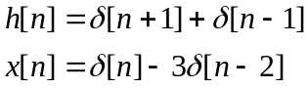
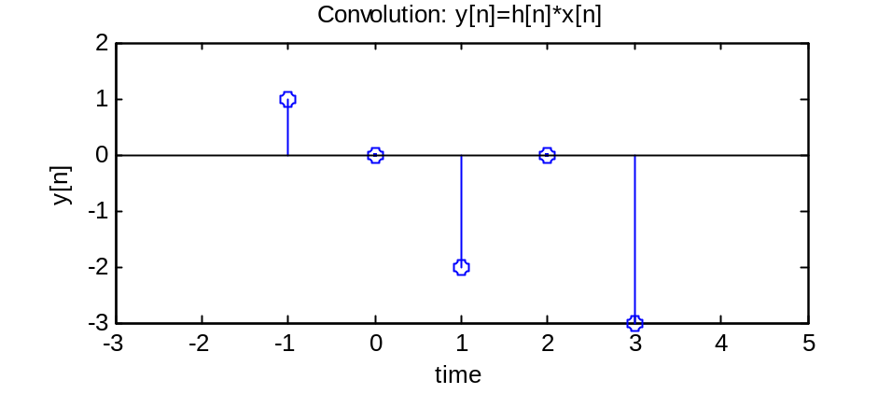
- Analytical works on separate papers.
- Impulse response: 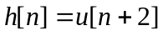
Input signal: 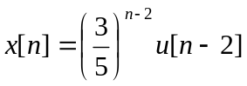
  - Compute and sketch the convolution of h[n] and x[n] (on separate paper).
  - Impulse response: 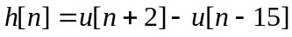
Input signal:
The convolution of the above signals would be like this:
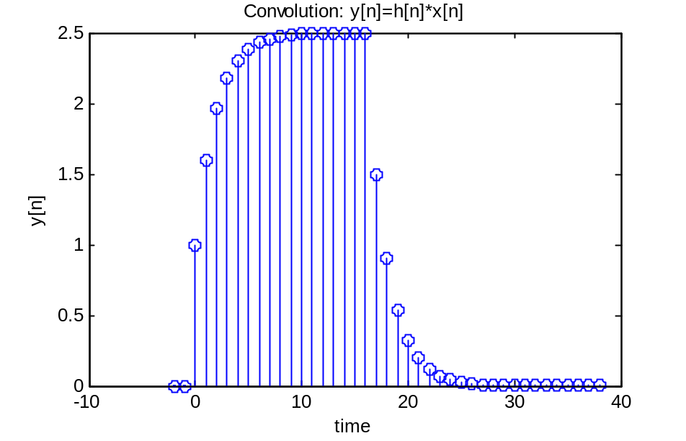
Because both impulse response and input signal are truncated, therefore only output signal y in time domain of 0~17 is correct. The rest after that is not correct.
- Block Convolutions:
- Using stem() function to compute the convolution of the signals 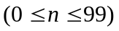:
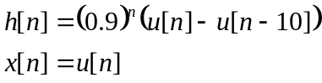
  - Convolution on the whole input signal and plot it with stem():
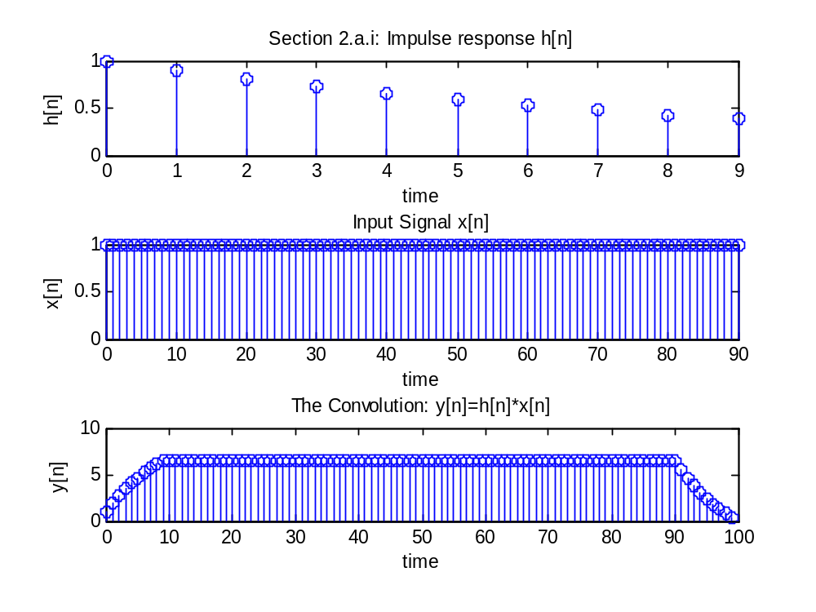
  - Divide the input signal x[n] into blocks with each block has a length of L (in this case L = 50). Do convolution on each block, shift each block to the right and implement the overlap-add block convolution.
The amount of shifting is depends on the current block which we are convoluting on and can be calculated:
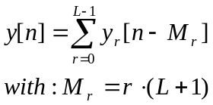
M_{r} = the mount of shifting.
The final convolution result would look the same as the convolution in part 2.a.i but a bit longer in time.
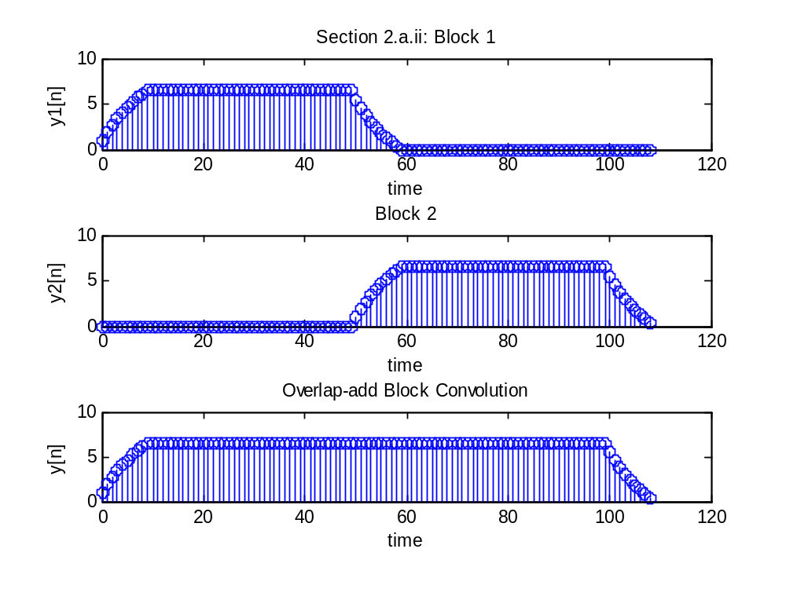
- For convenient, we will use a function called oafilt(h,x,L) to implement the overlap-add block convolution. The Matlab source code for this function is in section Appendix. This function will accept three inputs: an impulse response h, an input signal x and the block length L (L should not be greater than or equal to the length of the input signal x).
- To test oafilt(h,x,L) function, we will use the same input signals from part 2.a but with different block length L.
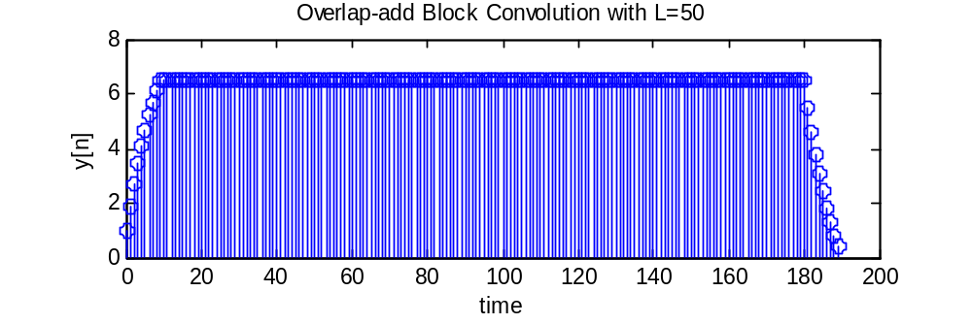
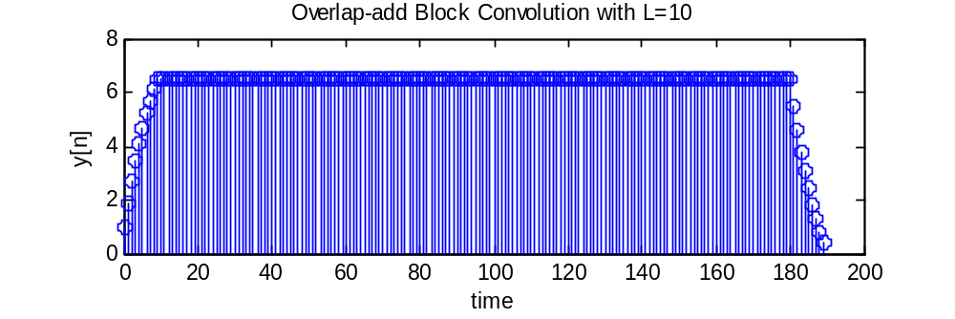
Or we could change the impulse response: 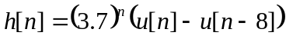:
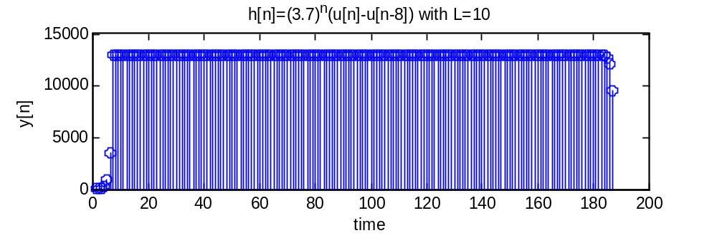
- Filtering a Noisy Audio Signal:
Load the data file proj1_data.mat into Matlab. This file contain an impulse response h, sampling frequency fs and vector signal sig which contain a noisy audio signal.
- I tried two functions:
- Soundsc(sig): it sound like the sound of an insect cicada making :D
- Sound(sig,fs): static sound.
- After filtering the noisy audio signal with our function oafilt(h,sig,L) and then play it with function sound(sig,fs). I heard a song. The word is “Hallelujah”. By changing the block length L doesn’t affect the output signal.
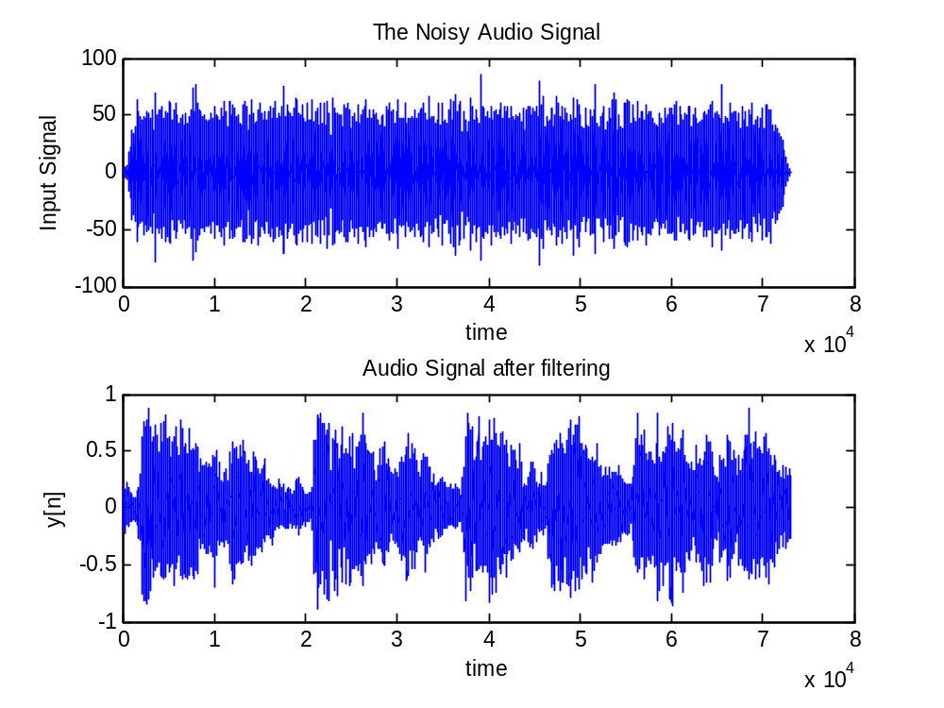
- Conclusion:
This project is very helpful. It helps me to understand more about the convolution and shows how useful of an LTI system is. I have learned how to use block convolution to process an input signal in real time. This project is also a good chance to review some of the Matlab useful functions like conv() and stem().
- Appendix:
This section contains all the Matlab source code for the above graphs.

%%% ECE 320 Lab Project 1
%%% Author: Quy Pham
%%% Date: 9/22/08

%--------------------------------------------------------------------------
%% Question 1. Basic convolution exercises
%--------------------------------------------------------------------------
%--------------------------------------------------------------------------
% 1.a: Plot the convolutio of h[n] and x[n]
%--------------------------------------------------------------------------
h_n = [1 0 1]; % -1:1
x_n = [1 0 -3]; % 0:2
y_n = conv(x_n,h_n);
ny = -1:3;
stem(ny, y_n);
axis([-3 5 -3 2]);
title('Convolution: y[n]=h[n]*x[n]');xlabel('time');ylabel('y[n]');

%%
%--------------------------------------------------------------------------
% 1.b: Analytical works on separate paper.
%--------------------------------------------------------------------------

%%
%--------------------------------------------------------------------------
% 1.c.i: Plot the convolution of h[n] and x[n]
%--------------------------------------------------------------------------
n = 0:50;
y = 5/2*(1-(3/5).^(n+1));
stem(n,y);
%%
h = ones(1,20);
n = 0:20;
x = (3/5).^(n-2).*(n>=2);
y = conv(h,x);
stem(y);
%%
%--------------------------------------------------------------------------
% 1.c.ii: Plot the convolution of a portion of signal h[n] and x[n]
%--------------------------------------------------------------------------
nh = -2:14;
nx = 0:24;
h = ones(1,17);
x = (3/5).^(nx-2).*(nx>=2);
y = conv(x,h);
ny = -2:38; % vector of time ny = (-2+0):(14+24)
stem(ny,y);
title('Convolution: y[n]=h[n]*x[n]');xlabel('time');ylabel('y[n]');

%--------------------------------------------------------------------------
%% Question 2: Block convolution
%--------------------------------------------------------------------------
% 2.a:
%--------------------------------------------------------------------------
ny = 0:99;
nh = 0:9;
h = (0.9).^nh;
nx = 0:90; % ny - nh
x = ones(1,91);
figure;
subplot(3,1,1);
stem(nh,h);
title('Section 2.a.i: Impulse response h[n]');xlabel('time');ylabel('h[n]');
subplot(3,1,2);
stem(nx,x);
title('Input Signal x[n]');xlabel('time');ylabel('x[n]');
%--------------------------------------------------------------------------
% 2.a.i:
%--------------------------------------------------------------------------
y = conv(h,x);
subplot(3,1,3);
stem(ny,y);
title('The Convolution: y[n]=h[n]*x[n]');xlabel('time');ylabel('y[n]');
%--------------------------------------------------------------------------
% 2.a.ii:
%--------------------------------------------------------------------------
IL = 100; % whole input length
L = 50; % block length
x0 = ones(1,L);
y0 = conv(h,x0);
x1 = ones(1,L);
y1 = conv(h,x1);
% L(y1) = L(x1) + L(h) - 1 = 50+10-1 = 59
% shift y1 by M = L+1 = 51
y1_shifted = [zeros(1,L) y1];
y0 = [y0 zeros(1,L)]; % need to be in the same length as y1_shifted
y = y0 + y1_shifted;
figure;
subplot(3,1,1);
ny0 = 0:(length(y0)-1);
stem(ny0,y0);
title('Section 2.a.ii: Block 1');xlabel('time');ylabel('y1[n]');
subplot(3,1,2);
ny1 = 0:(length(y1_shifted)-1);
stem(ny1,y1_shifted);
title('Block 2');xlabel('time');ylabel('y2[n]');
subplot(3,1,3);
% L(y1_shifted) = 50+59 = 109.
ny = 0:(length(y)-1); % 109 points
stem(ny,y);
title('Overlap-add Block Convolution');xlabel('time');ylabel('y[n]');

%--------------------------------------------------------------------------
% 2.b.i:
%--------------------------------------------------------------------------
function y = oafilt( h, x, L)

if (L >= length(x))||(L < 0)
error('The input segment length should be positive and less than the input signal length');
end
% number of blocks
blocks = ceil(length(x)/L);
% duplicate signal x
x_tmp = x;
% block: y = conv(x,h).
% length(y) = length(1 block) + length(h) - 1
y = zeros(1,(L+(length(h)-1)));
% process thru every blocks, except last block (it may not in length of L)
for i=1:blocks
if length(x_tmp) < L % if this is the last block and its length is less than L
% then add zeros to the end of it to make its length = L
%x0 = [x_tmp zeros(1,(L-length(x_tmp)))];
x0 = x_tmp(1:end);
else % not the last block
% extract first blocks from the whole signal
x0 = x_tmp(1:L);
end
% trash first block, keep the rest
x_tmp = x_tmp((L+1):end);
% do convolution on the current block
y_tmp = conv(x0,h);
% shift y_tmp by L+1
y_tmp = [zeros(1,(i-1)*L) y_tmp];
% after shifted, length(y_tmp) changed
% y need to be in the same length as y_tmp in order to sum
y = [y zeros(1,(length(y_tmp)-length(y)))];
% sum up blocks
y = y + y_tmp;
end

end
%--------------------------------------------------------------------------
% 2.c:
%--------------------------------------------------------------------------
nh = 0:7;
h = (3.7).^nh;
x = ones(1,181);
L = 10;
y = oafilt(h,x,L);
ny = 0:length(y)-1;
stem(ny,y);
title('h[n]=(3.7)^n(u[n]-u[n-8]) with L=10');xlabel('time');ylabel('y[n]');
%--------------------------------------------------------------------------
%% Question 3. Filtering of a Noisy Audio signal
%--------------------------------------------------------------------------
% 3.a:
%--------------------------------------------------------------------------
% load proj1_data.mat
%soundsc(sig);
% it sound like the sound of an insect cicada making :D
sound(sig,fs);
% it sound like the static sound.
%--------------------------------------------------------------------------
% 3.b:
%--------------------------------------------------------------------------
L = 10;
% the input signal and impulse reponse is in nx1 matrix
% so we need to do transpose(h) and transpose(sig) to convert them to 1xn
% matrix before plug them in oafilt() function.
y = oafilt(h.',sig.',L);
sound(y,fs);
% No difference when changing block length L
% I heard a song. The word "Hallelujah".
%%
subplot(2,1,1);
n = 0:length(sig)-1;
plot(n,sig);
title('The Noisy Audio Signal');xlabel('time');ylabel('Input Signal');
subplot(2,1,2);
n = 0:length(y)-1;
plot(n,y);
title('Audio Signal after filtering');xlabel('time');ylabel('y[n]');

